Experiment 16:
Source code:
#include <reg51.h>
void serial_ISR(void) interrupt 4
{
char ch;
if (RI == 1)
{
ch = SBUF; // Read character from keyboard
RI = 0; // Clear receive interrupt flag
SBUF = ch; // Send the same character back
}
if (TI == 1)
{
TI = 0; // Clear transmit interrupt flag
}
}
void main()
{
TMOD = 0x20; // Timer 1, Mode 2
TH1 = 0xFD; // 9600 baud rate
SCON = 0x50; // Serial mode 1, receiver enabled
TR1 = 1; // Start Timer 1
ES = 1; // Enable serial interrupt
EA = 1; // Enable global interrupt
while(1);
}

a)Displaying a message
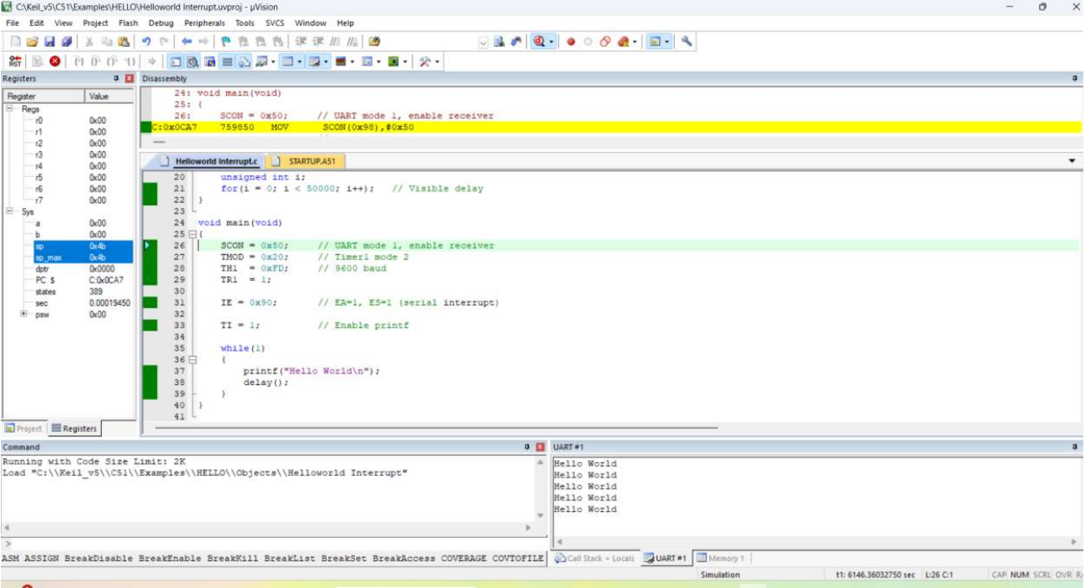

b)During interruption
